Ai marketing agent
Documentation
Made on :n8n
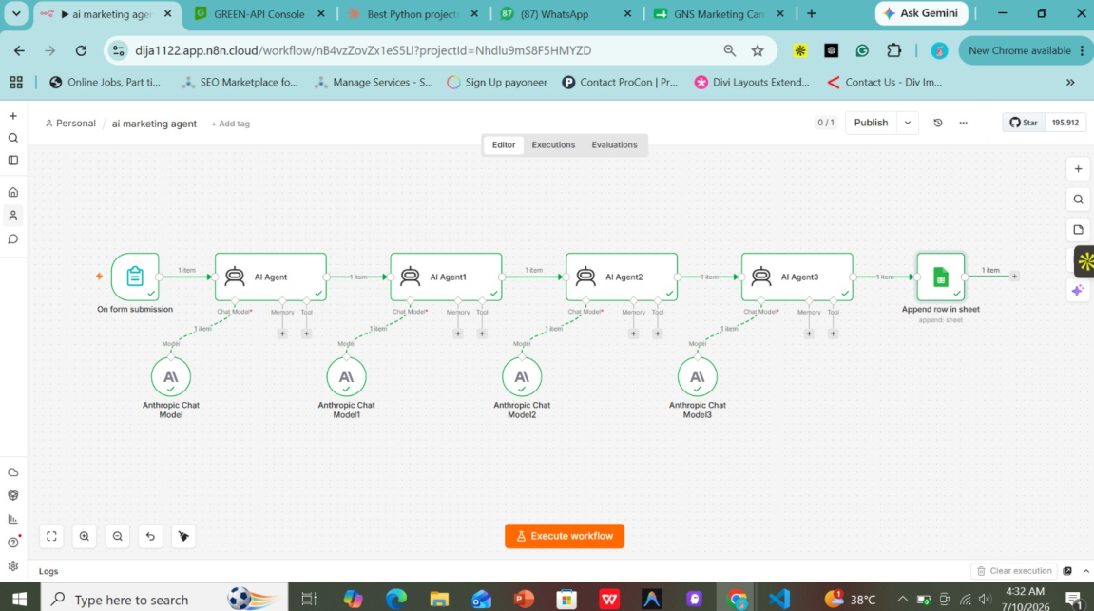
2. AI Marketing Agent
Purpose
Automates end-to-end marketing content generation, market research, and campaign strategy by routing form submissions through a multi-agent AI pipeline and logging outputs directly into Google Sheets.
Inputs
Marketing form submission data (target audience, product details, campaign goals, tone of voice, content requirements)
Workflow
- A new marketing request or campaign brief is submitted via the web form ("On form submission" trigger).
- AI Agent (Research & Strategy): Processes initial input using the Anthropic Chat Model to analyze target demographics and build campaign hooks.
- AI Agent 1 (Copywriting & Messaging): Drafts tailored marketing copy, ad scripts, or email campaigns based on the strategy.
- AI Agent 2 (Optimization & Refinement): Reviews the generated copy for SEO alignment, brand tone, engagement optimization, and clarity.
- AI Agent 3 (Final Review & Formatting): Formats all outputs into structured marketing assets ready for execution.
- The compiled campaign strategy and copy are logged automatically into Google Sheets ("Append row in sheet").
Outputs
Structured marketing strategies, optimized copy/ad creative texts, campaign roadmaps, and appended Google Sheets records
How It Works
When a user submits a marketing brief via the form, the workflow triggers a sequential multi-agent chain powered by Anthropic LLM models. Each specialized AI agent builds on the output of the previous one—moving from market analysis to copy generation, refinement, and final formatting—before saving the finalized marketing assets into a centralized Google Sheet without requiring manual coordination.

